Discussion Forum- [deadbydaylight](https://forum.deadbydaylight.com/en/discussion/18783/the-dead-by-daylight-meme-thread?__cf_chl_jschl_tk__=0c9260e3ff48f2f2d86f6f403833c83a989a1fc3-1589912616-0-AQ62VOPHsp95X5znvizbe5qBVUtTm-yKs1mQ0Tqw_GDMoKDk9IeVN28R9toQvYRAx46i8MsCAdknvvHRhNIYQ5eEGNiUiFtISfQqqhV-K_Jp69z5l30wzXBjPTC2Bd82JUELxF3Q4qwbvrvBew082TymkFIFc9EZpBV6C5UjmYQqEpUNL4vPOMo7_lCNA4vT4Cy7FITGChWaOpRWK8ADnJi-jjP97xX9XdK7Da_9156J36LQSSLivefL-wcwRwz7GmcebjyGZ1zynRHhR9te77z3T3bObuCTlFz9Qb5lSMQn6YjfQClHaonJlnaGDbtHN5Qkz1gzeTioaGT8UOujVa5UPIyHkHSXLA3bztGulQwuCr3lT-aore0XVgESsK6OsQcfypfd_V2zkzbynXYoegg)

**Id**: 1

**Name:** PeasantPeasant

**Comment**: After seeing @No_Mither_No_Problem 's Thread about "Is this a pigeon?" memes I decided I'd make a thread just about Dead by Daylight memes in general. Feel free to contribute, I recommend using imgflip.com/memegenerator 's meme generator.

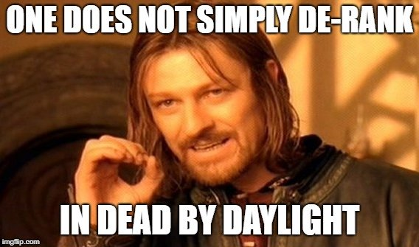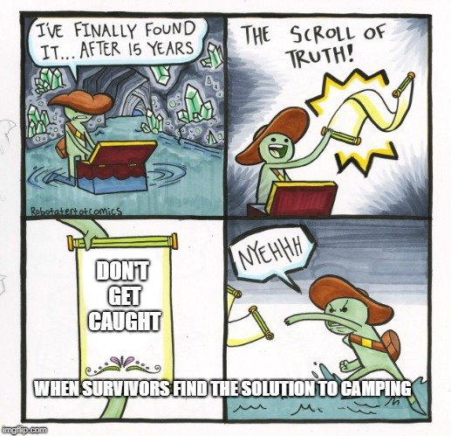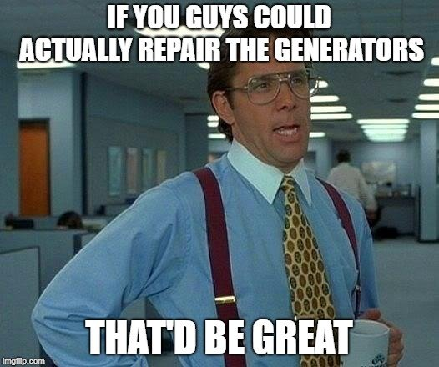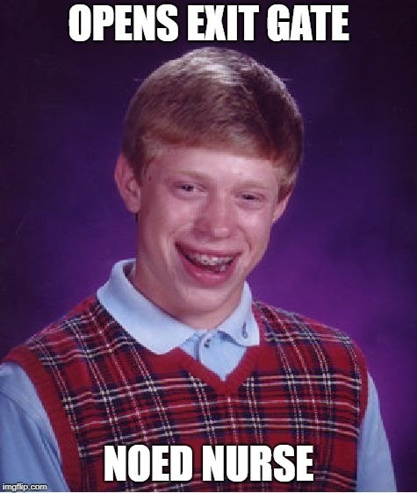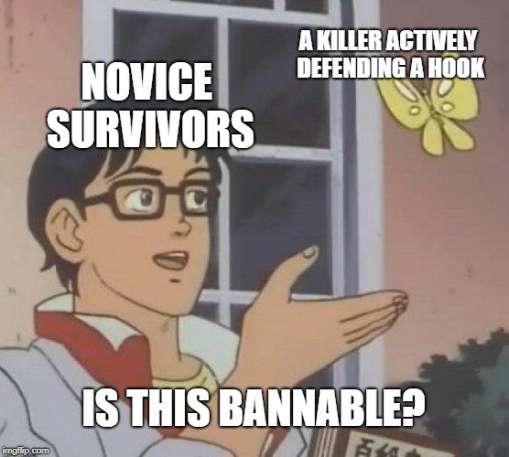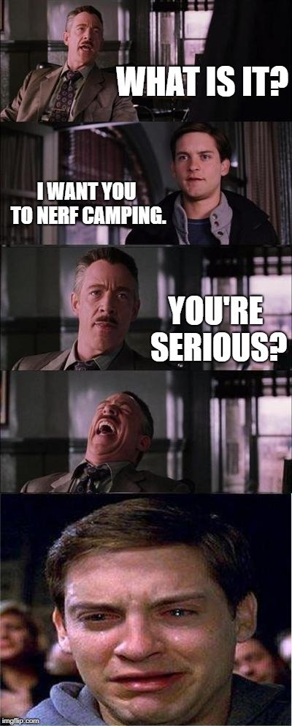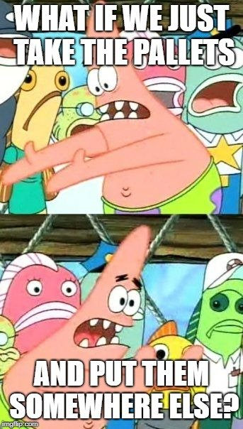

**Time**: September 2018

**Id**: 2

**Name**: RuneStarr

**Comment**: Meme dump yessss. Sorry it's a lot, and not even close to my full collection.

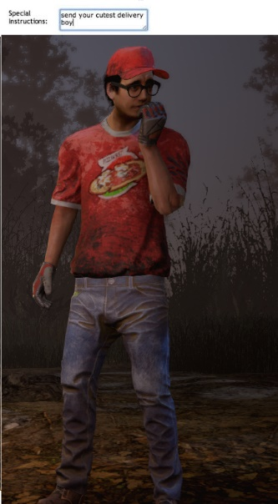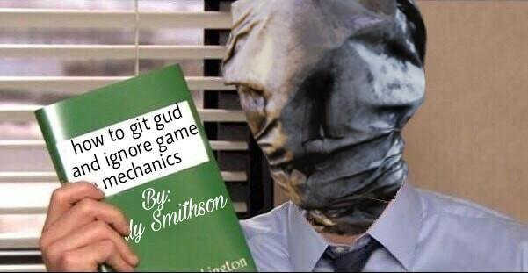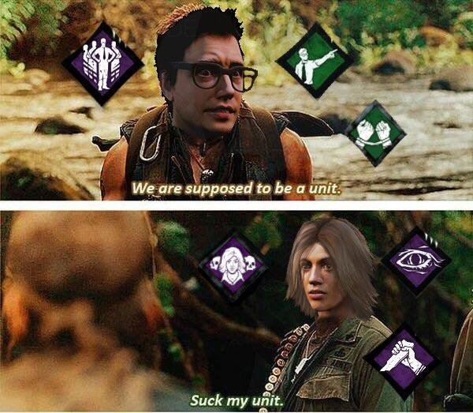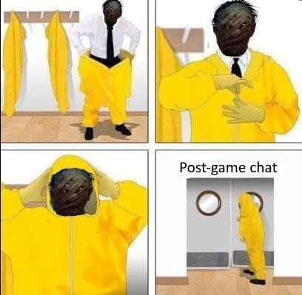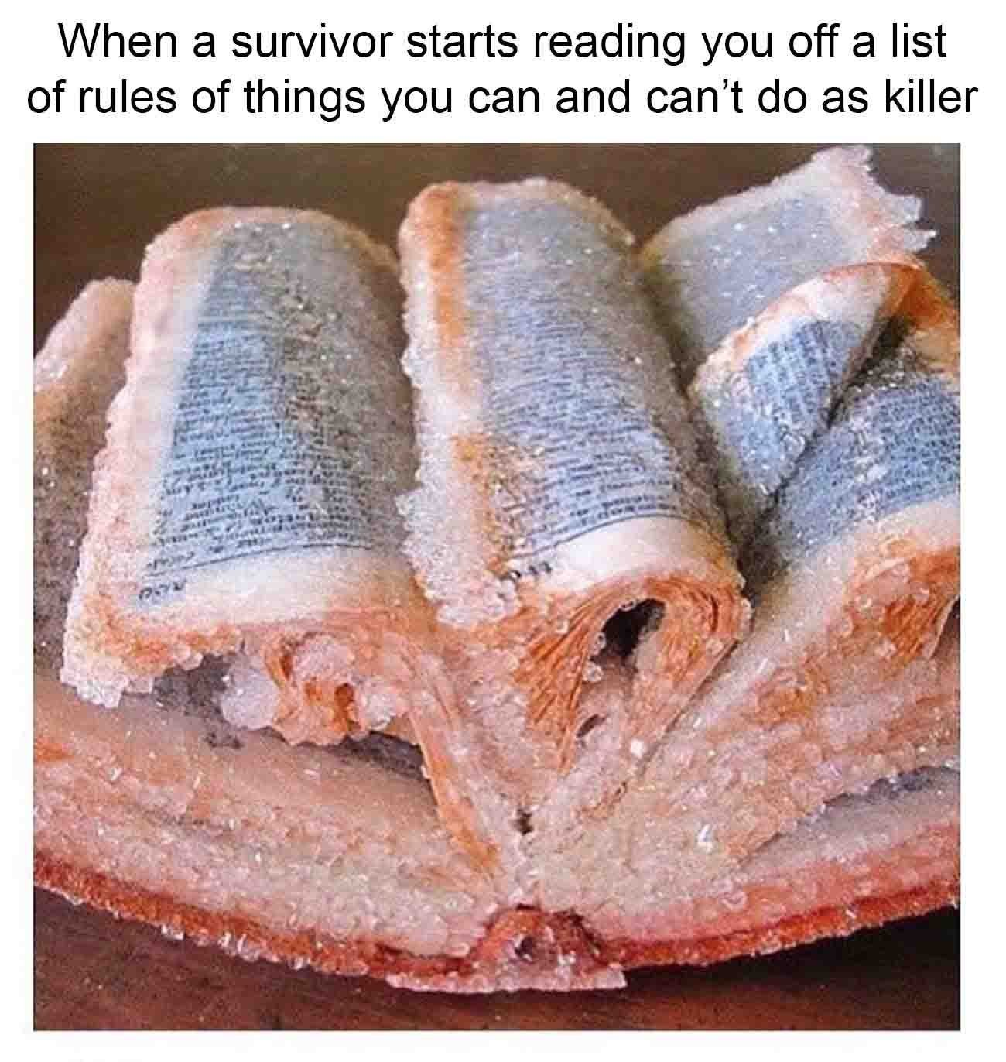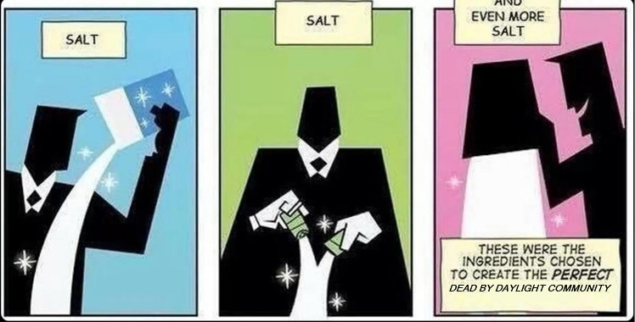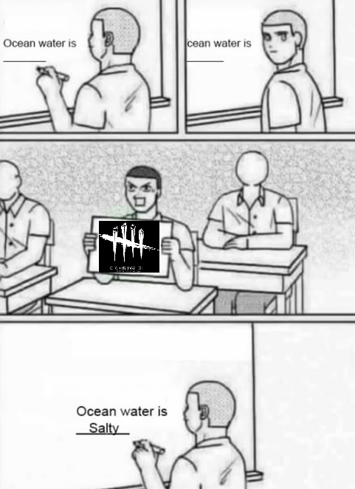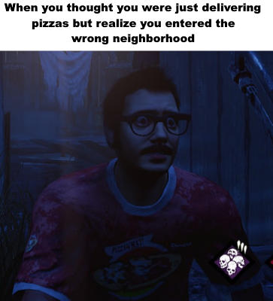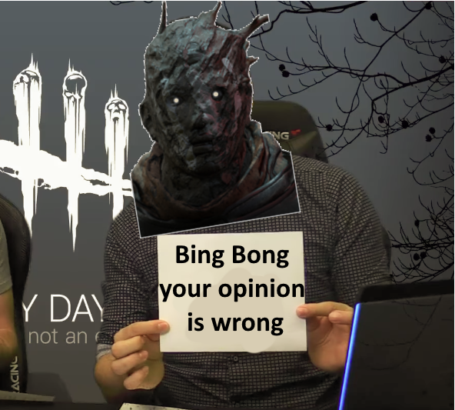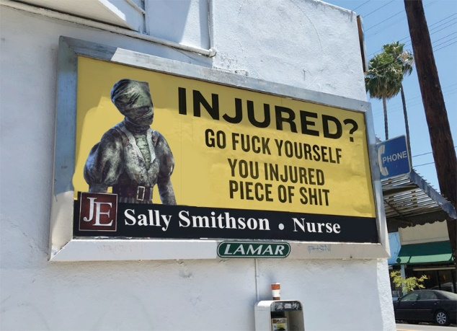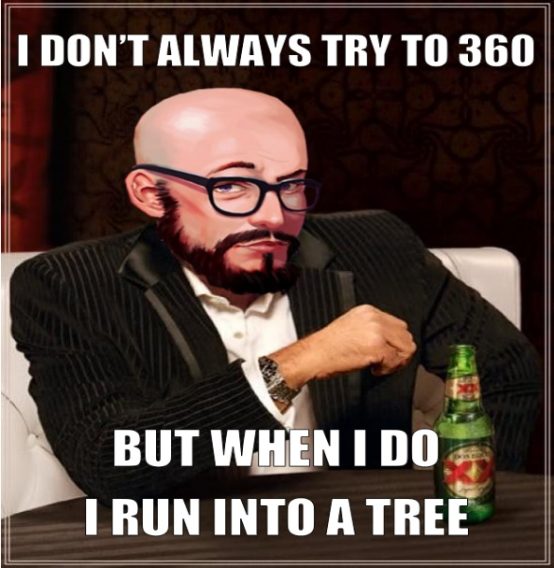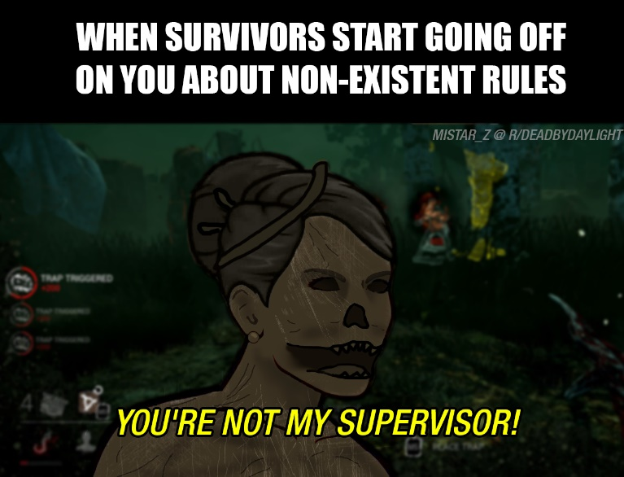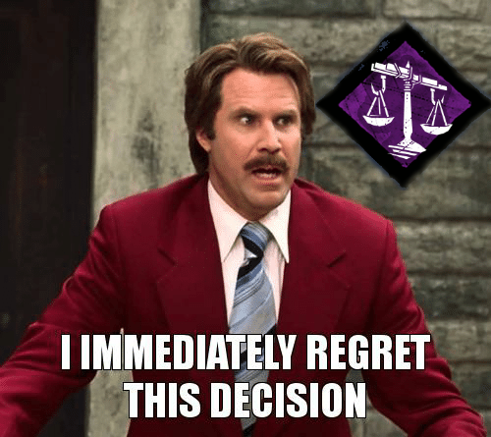

**Time**: September 2018

**Id:** 3

**Name:** Peasant

**Comment**: This is how all newer Dead by Daylight players act:

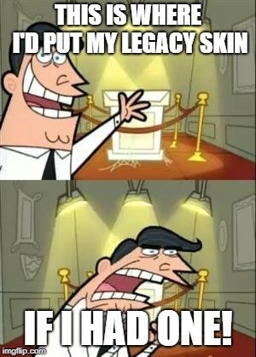

**Time**: September 2018

**Id:** 4

**Name:** PigNRun

**Comment**: I just love this thread, lol. Keep them coming.

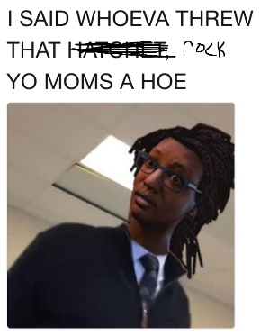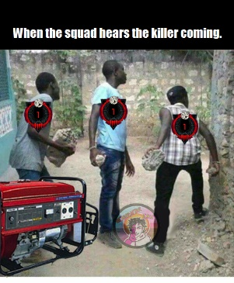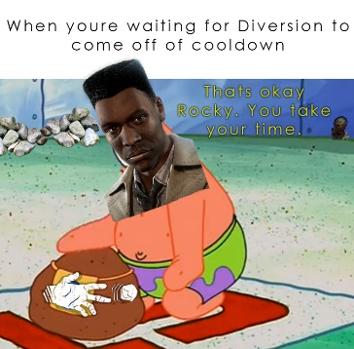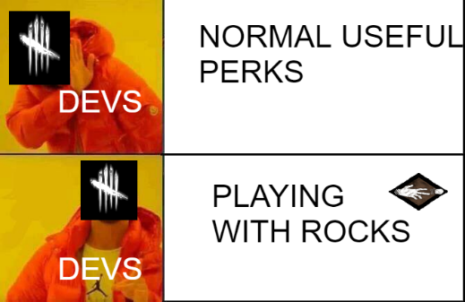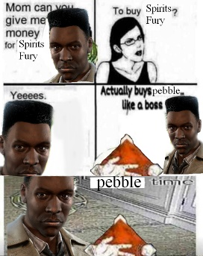

**Time**: September 2018

**Id:** 5

**Name:** MisterCremaster

**Comment**:

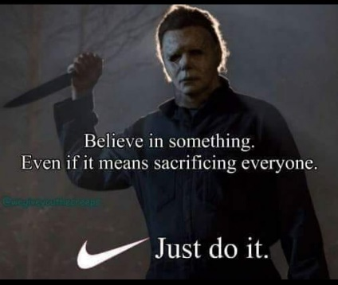

**Time**: September 2018

**Id:** 6

**Name:** Oblitiry

**Comment**:

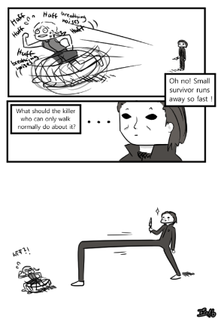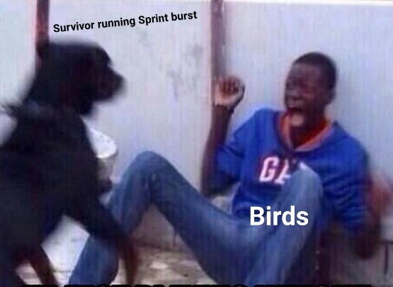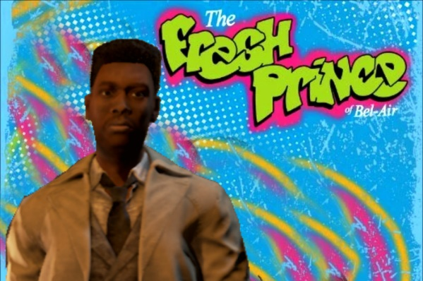

**Time**: September 2018

**Id:** 7

**Name**: Vietfox

**Comment**:

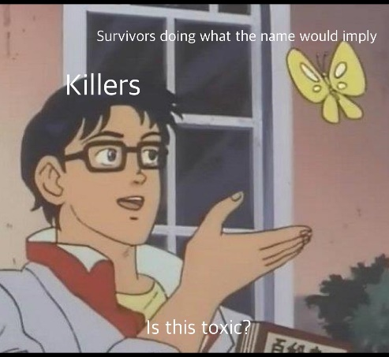

**Time**: September 2018

**Id:** 8

**Name**: PhantomMask20763

**Comment**: I have more but these are possibly my favorite

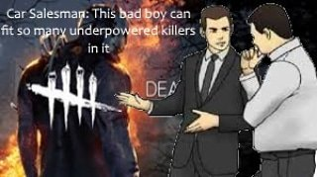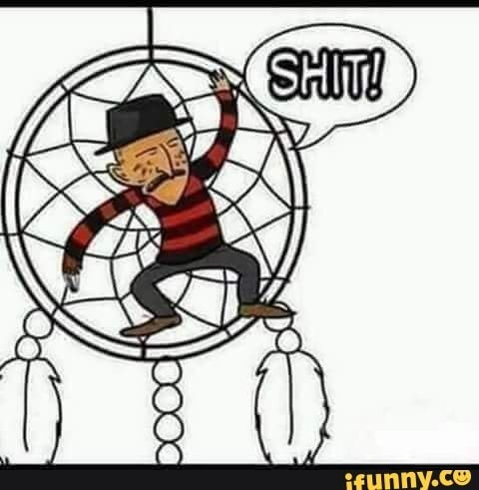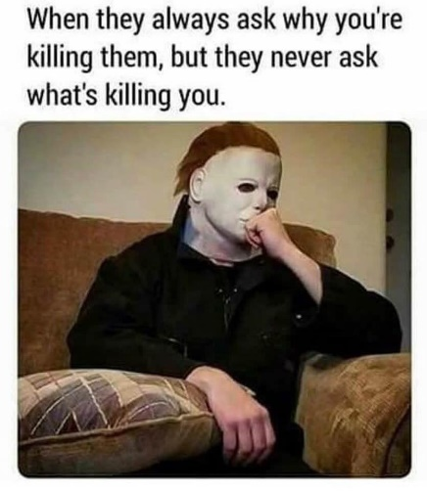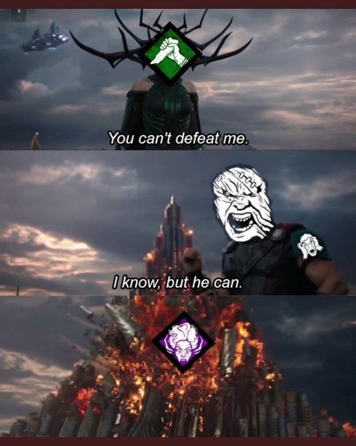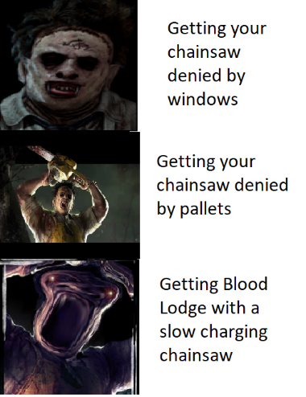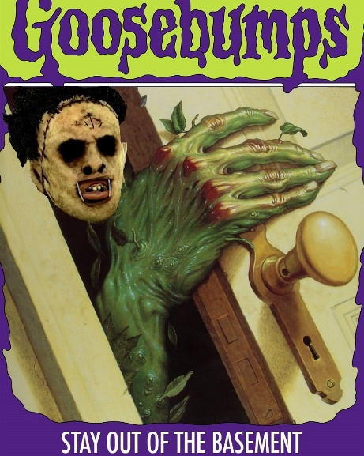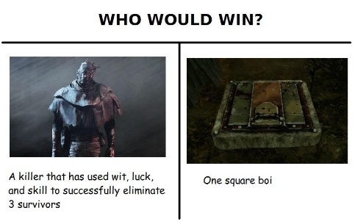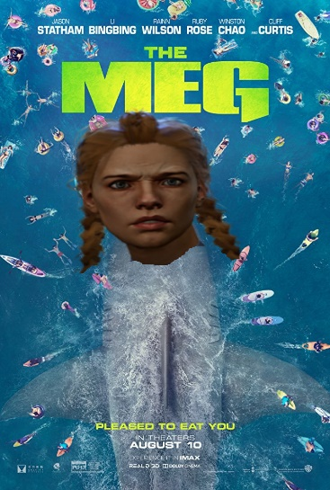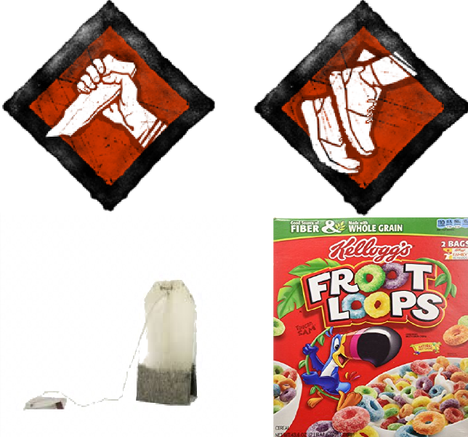

**Time**: September 2018

**Id:** 9

**Name**: PhantomMask20763

**Comment**:

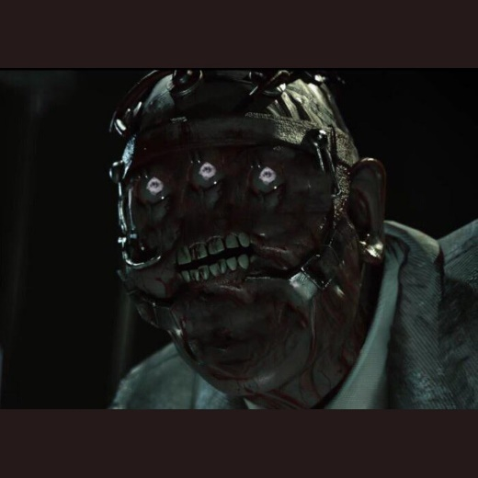

**Time**: September 2018

**Id:** 10

**Name**: TheHourMan

**Comment:** There's a couple that I made

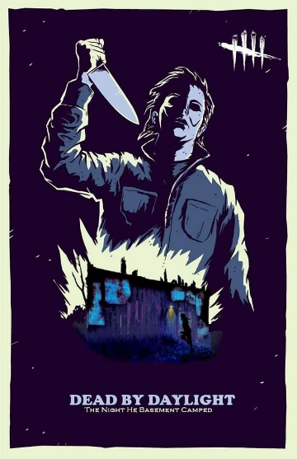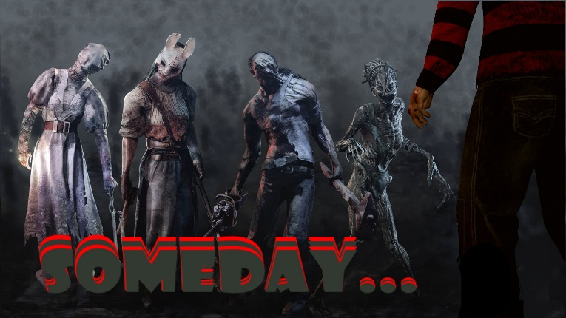

**Time**: September 2018

**Id:** 11

**Name**: Peasant

**Comment:** Just a few simple memes about/for those special survivors.

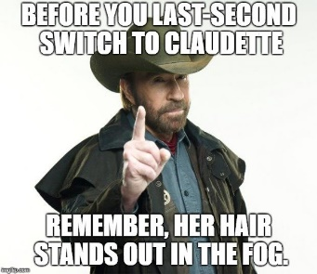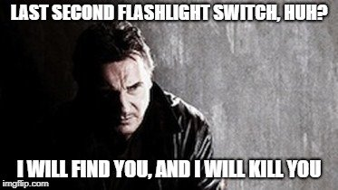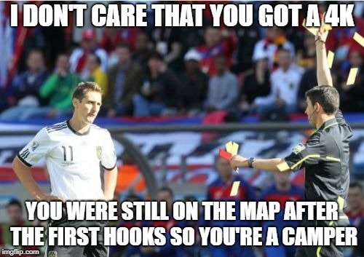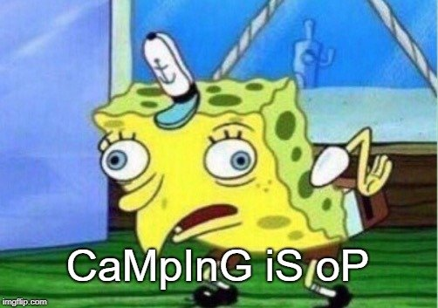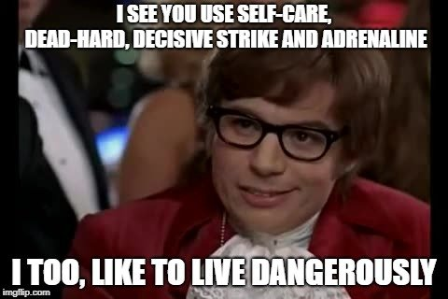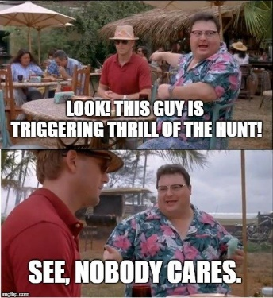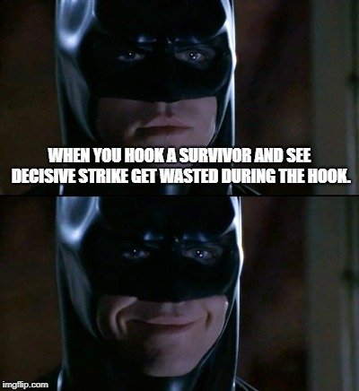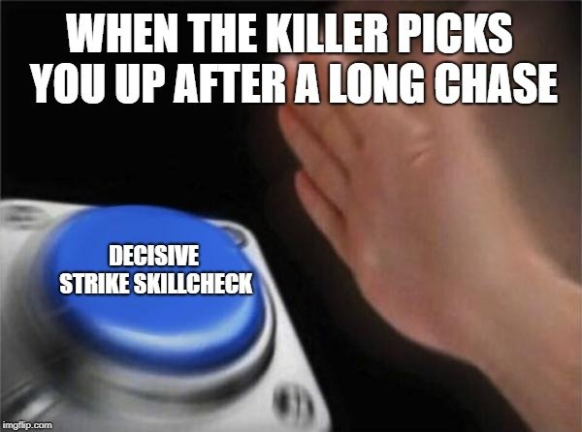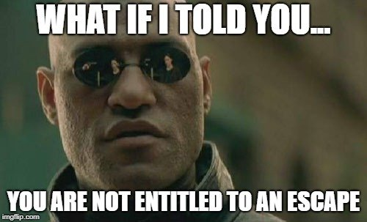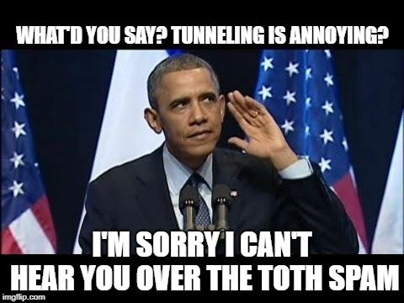

**Time**: September 2018

**Id:** 12

**Name**: PigNRun

**Comment**: Peasant said:

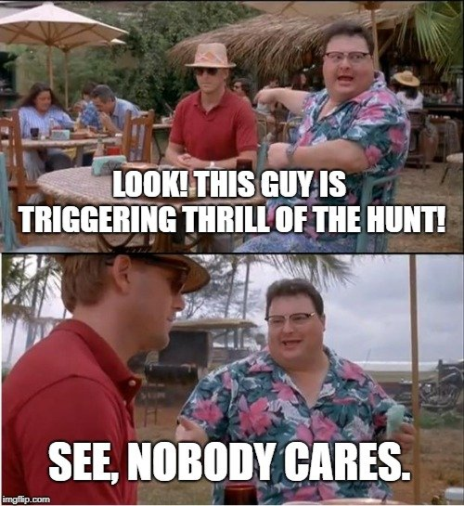

Props for this one.

**Time**: September 2018

**Id:** 13

**Name**: Peasant

**Comment**: PigNRun said: show previous quotes. Props for this one. Yeah, I had read earlier that some survivors are spamming the totem. Once I stumbled across the meme background in the generator I couldn't resist.

**Time**: September 2018

**Id:** 14

**Name**: SNTD

**Comment**: @PhantomMask20763 said: I have more but these are possibly my favorite. hey look, that meme i made. the survivor starter pack

**Time**: September 2018

**Id:** 15

**Name**: PhantomMask20763

**Comment**: SNTD said: show previous quotes hey look, that meme i made. the survivor starter pack Really well thanks for that beautiful meme one of my favorites

**Time**: September 2018

**Id:** 16

**Name**: SNTD

**Comment**: @PhantomMask20763 said: SNTD said: @PhantomMask20763 said: I have more but these are possibly my favorite hey look, that meme i made. the survivor starter pack Really well thanks for that beautiful meme one of my favorites thanks!

**Time**: September 2018

**Id:** 17

**Name**: Rattman

**Comment**: Gonna drop this here



**Time**: September 2018

**Id:** 18

**Name**: Billou

**Comment**: Yes meme! A corner to post my [BAD WORD], here's one I made earlier about one of my game as a killer

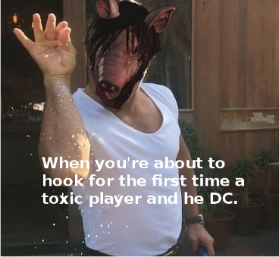

**Time**: September 2018

**Id:** 19

**Name**: No_Mither_No_Problem

**Comment**: Oi Oi guess who’s back

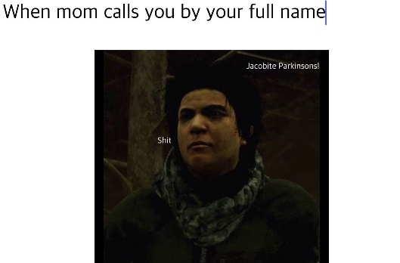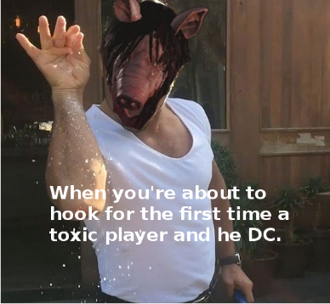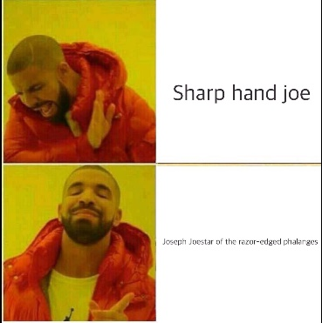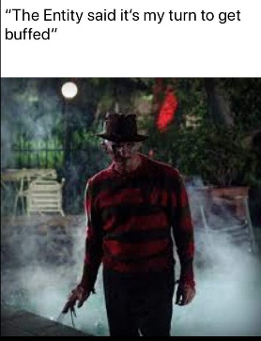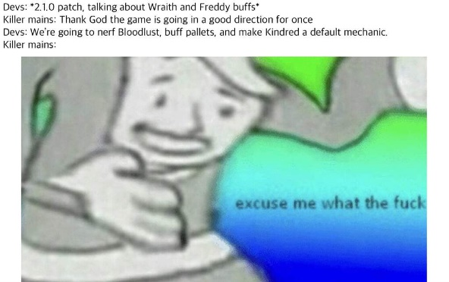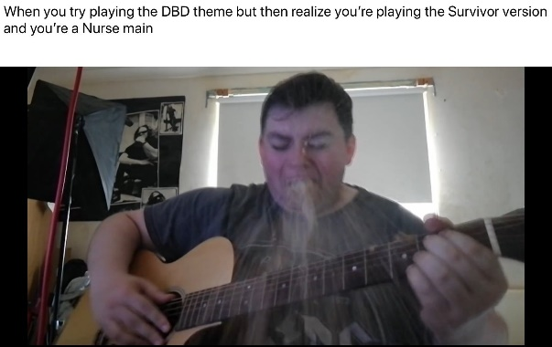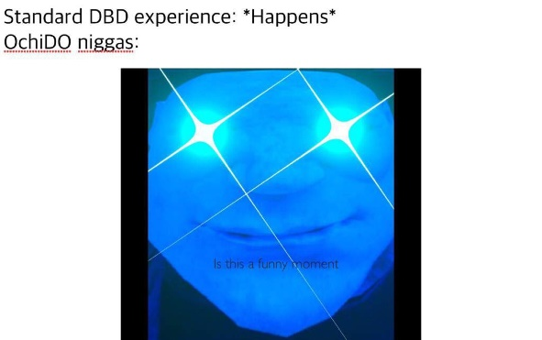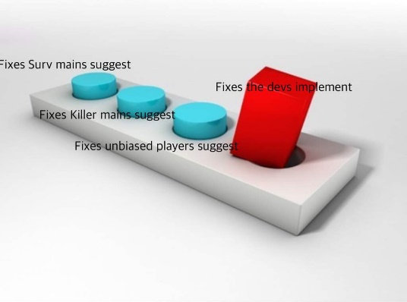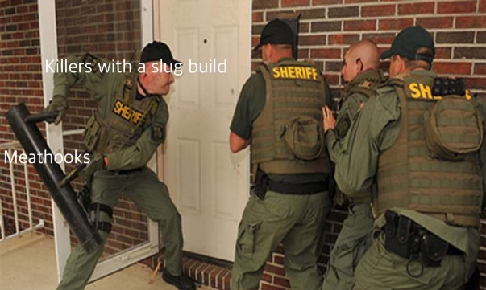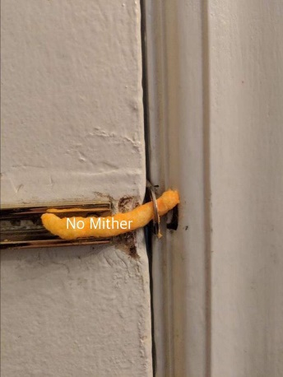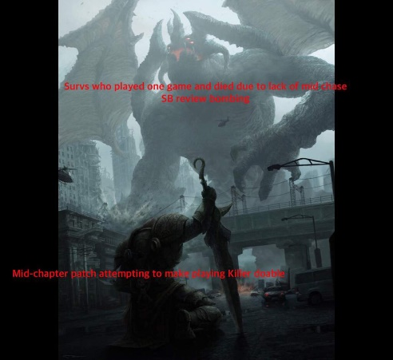

**Time**: September 2018

**Id:** 21

**Name**: No_Mither_No_Problem

**Comment**: @TheHourMan said: There's a couple that I made THE NIGHT HE BASEMENT CAMPED

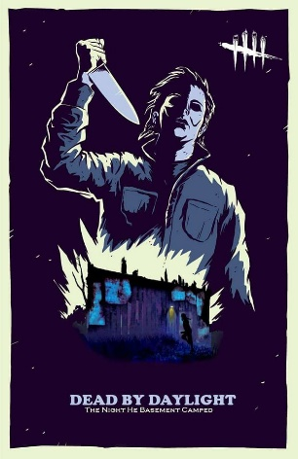

**Time**: September 2018

**Id:** 22

**Name**: No_Mither_No_Problem

**Comment**: Boom



**Time**: September 2018

**Id:** 23

**Name**: No_Mither_No_Problem

**Comment**: Y’all want some more?

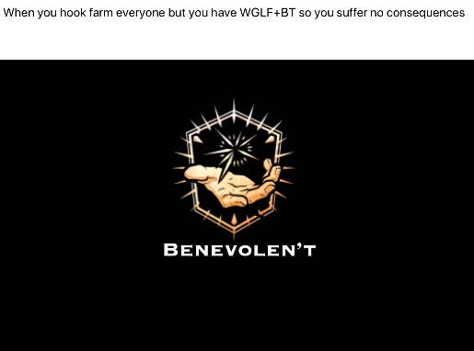

**Time**: September 2018

**Id:** 24

**Name**: RuneStarr

**Comment**: Not even sorry for ruining candle wraith for anyone.

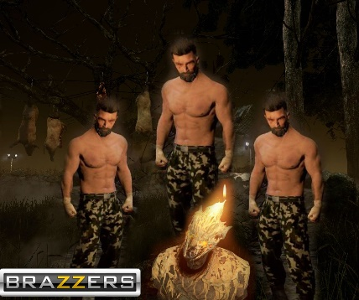

**Time**: September 2018

**Id:** 25

**Name**: No_Mither_No_Problem

**Comment**: @RuneStarr said: Not even sorry for ruining candle wraith for anyone.

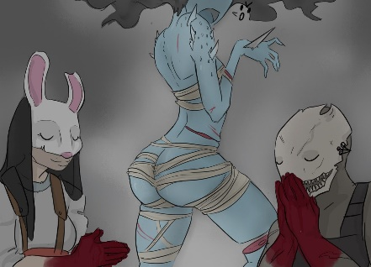

**Time**: September 2018

**Id:** 26

**Name**: RuneStarr

**Comment**: No_Mither_No_Problem said: show previous quotes . #Bless that t h I c c booty



**Time**: September 2018

**Id:** 27

**Name**: No_Mither_No_Problem

**Comment**: : @RuneStarr said: No_Mither_No_Problem said: @RuneStarr said: Not even sorry for ruining candle wraith for anyone. #Bless that t h I c c booty Here, have a cropped NSFW DBD meme.

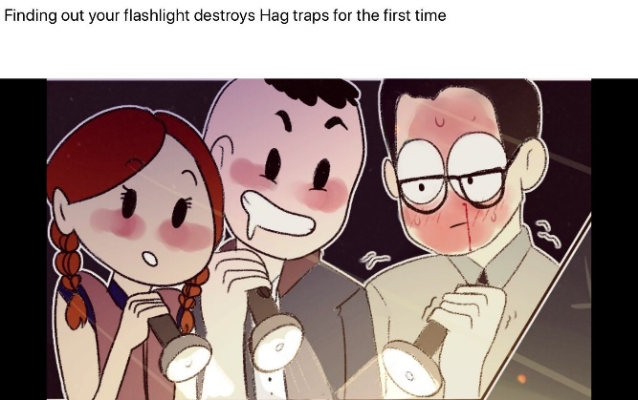

**Time**: September 2018

**Id:** 28

**Name**: No_Mither_No_Problem

**Comment:** Here, have another cropped NSFW DBD meme

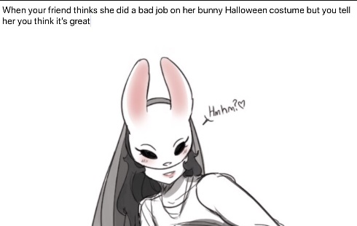

**Time**: September 2018

**Id:** 29

**Name**: No_Mither_No_Problem

**Comment:** @Vietfox said: XD That’s my brainlet meme



**Time**: September 2018

**Id:** 30

**Name**: ditchwitch

**Comment**: half of these are impact font memes wheeze

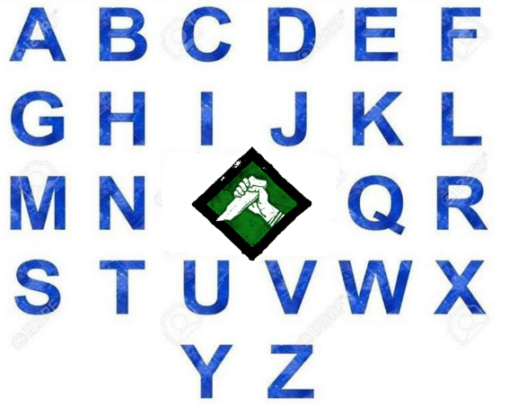

**Time**: September 2018

**Id:** 31

**Name**: Peasant

**Comment:** @ditchwitch said: half of these are impact font memes wheeze

I'm new to meme creation so all I have to go by is what I can remember of past memes. Would you prefer a different font?



**Time**: September 2018